Product Vision

Product vision is the future aspirations or goals that a business product hopes to achieve in the future. It consists of a product vision statement that describes how and in what terms the stakeholders of the product want to achieve their vision of the product.
Every product owner has a dream of their product as in what terms it would affect the target market, how will it benefit the consumers, and a road map to ensure the productivity of the brand in the long run.

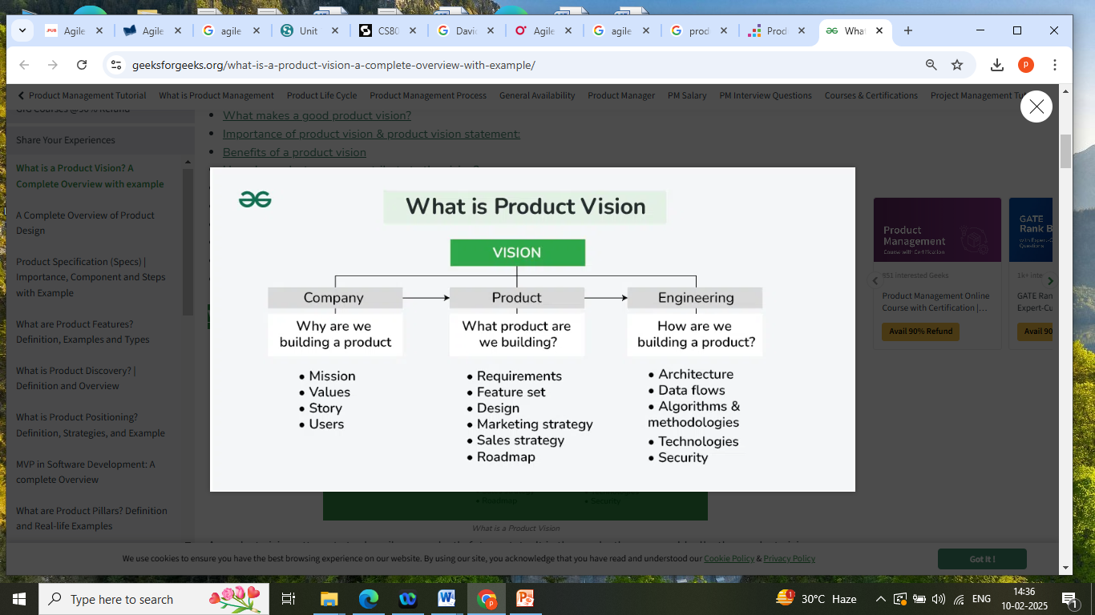
A product vision attempts to describe a product's future state. It is the product's essence. Ideally, the product vision will serve as a guide for stakeholders, reminding them of the general direction the product should take and the team's common goals.

When do you need a product vision?
- It is critical to begin a new product with a vision.
- However, the product vision will likely be tweaked or even changed over time.
- A new product should always begin with a clearly defined vision statement, regardless of the industry, product, or team.

What makes a good product vision?
- A good product vision is customer-focused. It complies with the needs of a customer while keeping in mind the future aspirations of the target audience. While removing any lofty thoughts, a good product vision provides a sense of understanding for the consumers.
- Being clear and concise, a vision that defines the path clearly and paves the way for future enhancement and development is clear. It must be short and crisp to make it clear to the employees as to what exactly is the long-term goal and how the company officials plan to expand.
- A vision that is future-oriented
- A future-oriented vision has a compelling nature and time to time orders the employees to continue working on the long-term goal. It ensures connectivity and adaptability while giving space for creativity and innovation along with sustainability and response.

- 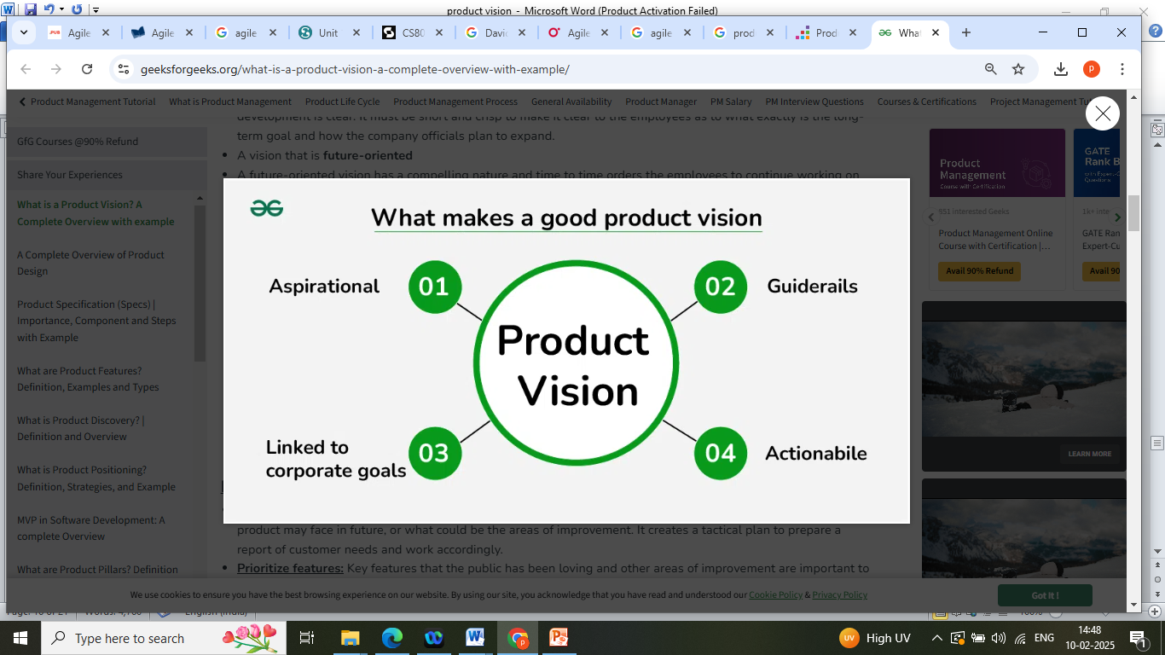
What makes a good product vision?

Importance of product vision & product vision statement:
- Roadmap: Developing a vision helps in an establishment of a roadmap that in the long run what all difficulties the product may face in future, or what could be the areas of improvement. It creates a tactical plan to prepare a report of customer needs and work accordingly.
- Prioritize features: Key features that the public has been loving and other areas of improvement are important to keep the customer base intact. It makes us customer focused and enhances existing features while giving a space to add new ones.
- Attracts audience: A captivating product statement attracts the audience to the product and company, much similar to the advertisements. For eg. The product vision statement of Instagram is "To capture & share the world's moments". This product vision statement is well enough capable to interact and attract the target audience.
- Knowing the crowd: A proper representation with statistics and graphs to know the audience is required to draft a product vision. What the company requires to provide the customers and how, how will any further changes upgrade or degrade the according to the needs of audience etc are needed for a product vision statement.

Benefits of a product vision:

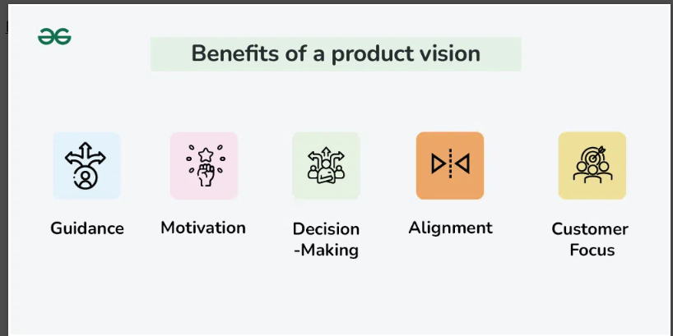

Benefits of a product vision
- Guidance: It serves as a guiding light, providing a clear direction for the team. This helps everyone understand the ultimate goal and purpose of the product.
- Motivation: A compelling product vision inspires and motivates team members. It gives them a reason to come to work excited and encourages them to put in extra effort to achieve the shared goal.
- Decision-Making: When faced with decisions, the product vision acts as a reference point. It helps team members make choices that align with the overall vision, preventing divergent or conflicting directions.
- Alignment: It ensures that everyone on the team is on the same page. The shared understanding of the product vision promotes unity and collaboration among team members.
- Customer Focus: A well-defined product vision often centers around addressing customer needs or solving a problem. This customer-centric approach helps in creating products that resonate with and benefit the target audience.

How do product owners contribute to the vision?

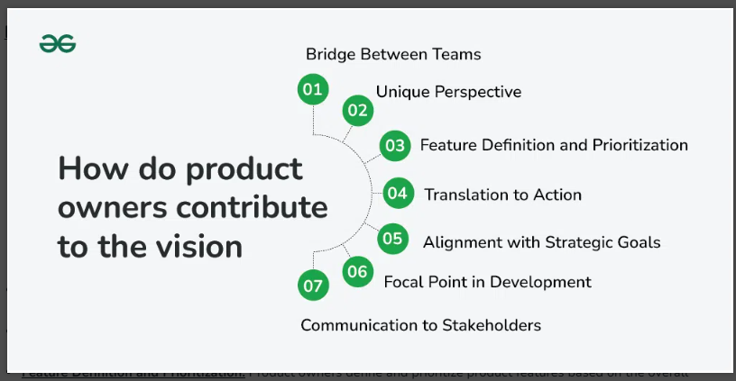

How do product owners contribute to the vision
- Bridge Between Teams: Product owners connect the product development team with stakeholders like customers, executives, and sales/marketing teams.
- Unique Perspective: Their close involvement provides them with a special understanding of what the product aims to achieve.
- Feature Definition and Prioritization: Product owners define and prioritize product features based on the overall product vision.
- Translation to Action: They articulate the vision into user stories and requirements, making it understandable and actionable for the development team.
- Alignment with Strategic Goals: This process ensures that the product aligns with the company’s strategic objectives.
- Focal Point in Development: Product owners play a key role in keeping the product vision at the center of decision-making, managing trade-offs, and navigating changes.
- Communication to Stakeholders: They communicate the product vision and roadmap to stakeholders, fostering understanding, alignment, and support across the organization.

Who defines a product vision statement?
The whole company is expected to put forth their ideas in order to form a product vision statement. It's the company employees who after research determine the needs and requirements of the public and accordingly give their ideas on how the vision of the product must be. In total, they look for the present needs while keeping in mind how in future they would have to reform the product. However, it's not the sole responsibility of the company owner to develop a vision. A product vision is expected to be dynamic and not static, formation which includes team work, an opportunity for the product to add value in the market and gear up for selling.

How to write a product vision statement?
The product vision statement should ensure complete alignment and clarity among development teams, stakeholders, and other stakeholders. To accomplish this, follow these four principles:
- Customer-centered: The vision statement should emphasize the value that the product will provide to customers.
- Ambition: Your product vision statement should be aspirational as possible. You don't want to release a mediocre product; you want to change the game!
- Differentiation: Your product vision statement should explain how this product will give your company a competitive advantage.
- The Future: What do you want people to remember about your product in the future? What kind of legacy should this product leave?

Product Vision Statement Template:
A good product vision is aspirational and customer focused. It consists of parameters such as target audience, customer needs, product name and it's description, unique benefits, why should the public use this product etc. It also includes the name of other companies in order to show a healthy competition and how is the product different from others. Below is a template for product vision statement formation :
For (target audience) who require to (needs), our (product) is a (material) from (company) that helps in (key benefits) and has features such as (product description). Unlike (company in competition), our product has (differentiating qualities).
A good product vision statement proves to be beneficial to both company, in order to enhance their product and increase the value in market, as well as the customers, who get an insight of how the product is and according to their needs, what all can it provide.

Examples of Product Vision:
Big companies such as Instagram, Google, Microsoft, Apple have delightful and captivating product visions which constitutes of the services they are providing, and those which they wish to plan in future:
Examples of Product Vision
- Amazon: Amazon's mission is to be the most customer-centric company on the planet, where customers can find and discover anything they might want to buy online.
- Apple: To provide its customers with the best user experience possible through innovative hardware, software, and services.
- Disney: Disney's vision is to be one of the world's leading producers and suppliers of entertainment and information.
- LinkedIn: LinkedIn's mission is to connect the world's professionals and help them become more productive and successful.
- Instagram: Instagram's mission is to capture and share the world's moments.
- Microsoft Surface: Unlike laptops, Surface can be used on the go without the need for an additional device.
- Sonos: Play music in every room of the house.
- Google: Google's mission is to provide one-click access to the world's information.

